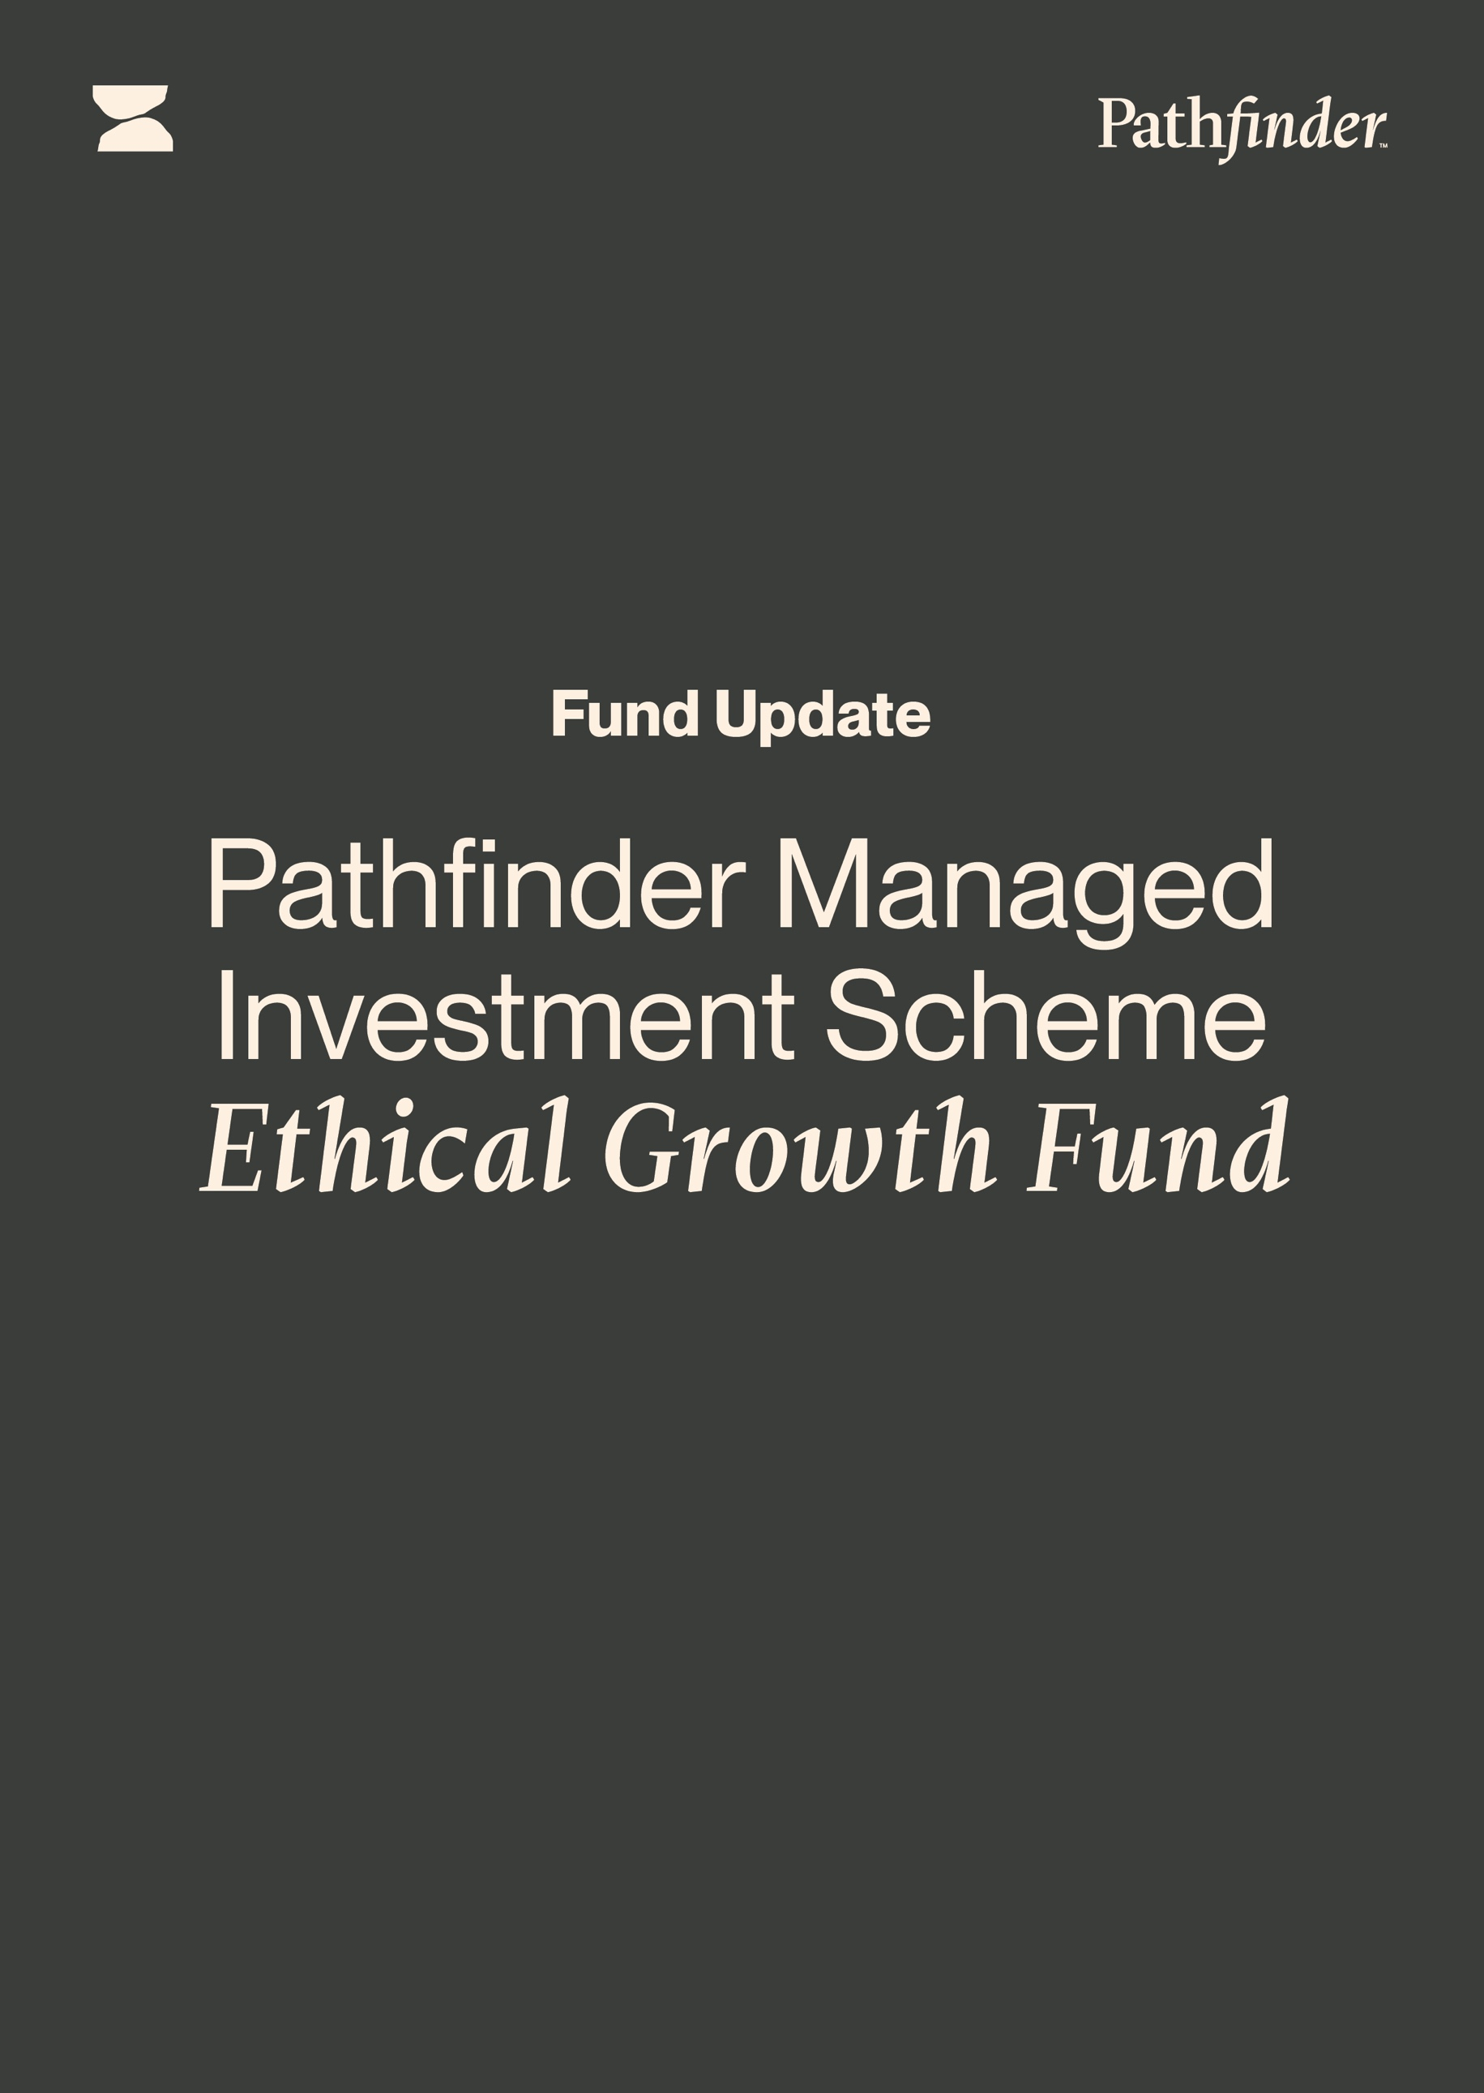
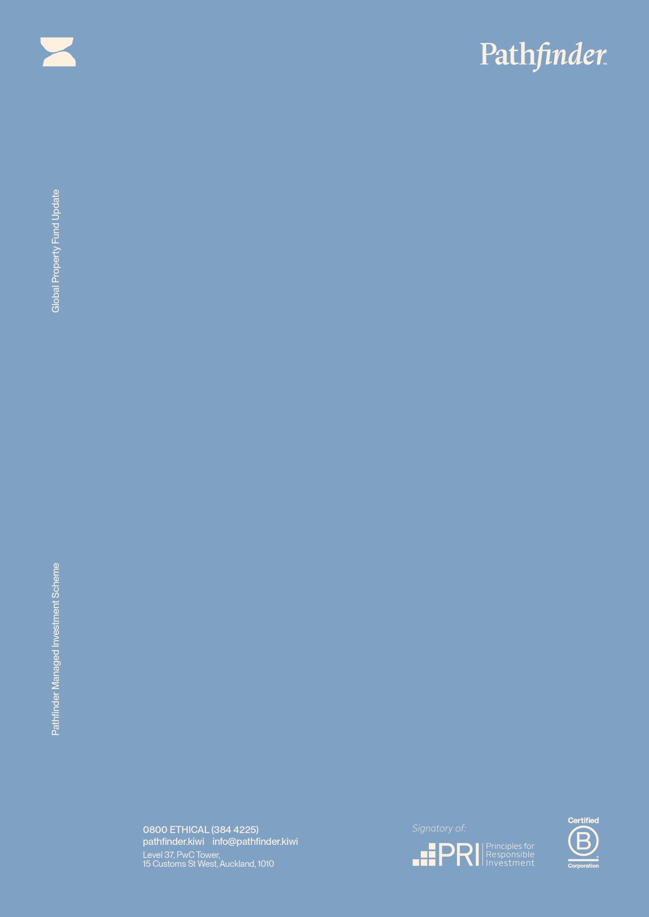
For the quarter end 31 December 2025
First made publicly available 13 February 2025

For the quarter end
31 March 2023

First made publicly available 3 May 2023

Fund Update for:
the Pathfinder Managed Investment Scheme
Pathfinder Ethical Growth Fund
Quarter ended 31 December 2025
This fund update was first made publicly available on 13 February 2025.

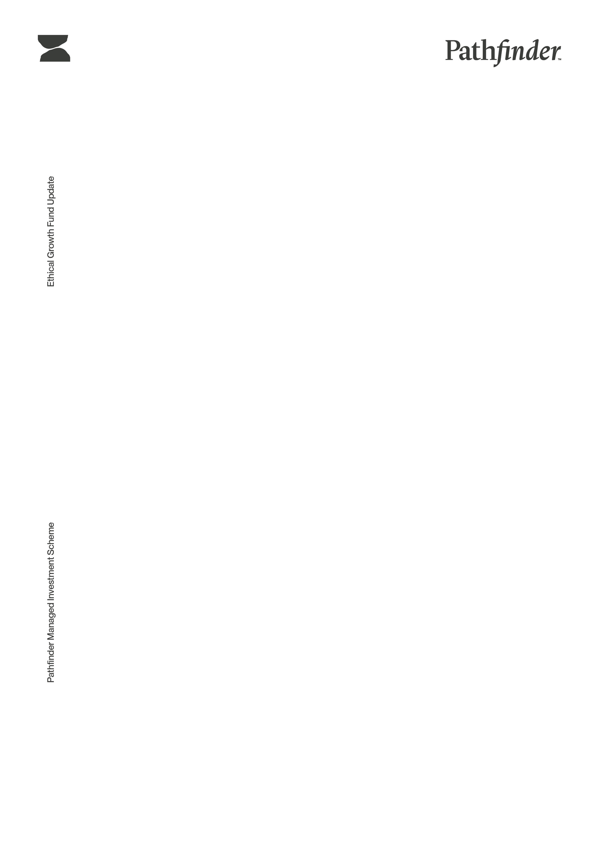
What is the purpose of this update?
This document tells you how the Pathfinder Ethical Growth Fund has performed and what fees were charged. The document will help you to compare the fund with other funds. Pathfinder Asset Management Limited prepared this update in accordance with the Financial Markets Conduct Act 2013. This information is not audited and may be updated.

Description of this fund
An ethical portfolio invested in growth and income assets.

Total value of the fund | $97,555,090.68
The date the fund started | 17 August 2020

What are the risks of investing?
Risk indicator for the Pathfinder Ethical Growth Fund:

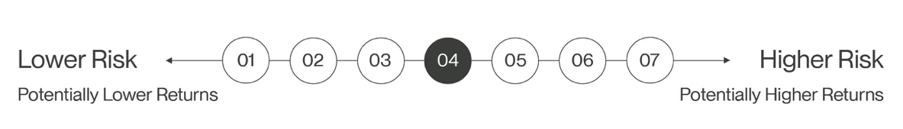

The risk indicator is rated from 1 (low) to 7 (high). The rating reflects how much the value of the fund’s assets goes up and down. A higher risk generally means higher potential returns over time, but more ups and downs along the way.
To help you clarify your own attitude to risk, you can seek financial advice or work out your risk profile at www.sorted.org.nz/tools/investor-kickstarter.

Note that even the lowest category does not mean a risk-free investment, and there are other risks that are not captured by this rating.

This risk indicator is not a guarantee of a fund’s future performance. The risk indicator is based on the returns data for the 5-year period from 1 January 2021 to 31 December 2025. While risk indicators are usually relatively stable, they do shift from time to time. The risk indicator will continue to be updated in future fund updates.

See the Product Disclosure Statement (PDS) for more information about the risks associated with investing in this fund.

How has the fund performed?
Pathfinder Ethical Growth Fund | Average over Past 5 years | Past year
Annual return  (after deductions for charges and tax) | 5.60% | 7.16%
Annual return  (after deductions for charges but before tax) | 6.10% | 7.96%
Market index annual return  (reflects no deductions for charges and tax) | 8.37% | 11.96 %

The market index annual return is the Morningstar® Target Allocation Index™: Growth Multisector for New Zealand, 100% non-New Zealand Fixed Interest in the Fund hedged to NZD, 0% other non-New Zealand assets hedged to NZD². The index is gross of dividends and tax except for International Equities and International Listed Properties, which are gross of dividends after deducting the tax withheld.

Additional information about the index is available on the offer register at https://disclose-register.companiesoffice.govt.nz/ (search Offers, using Offer OFR10780, Documents, Other Material Information).
See note 2 for further information on the market index.

Annual Return Graph

This shows the return after fund charges and tax for each year ending 31 March since the fund started. The last bar shows the average annual return since the fund started, up to 31 December 2025.

Important: this does not tell you how the fund will perform in the future.

Returns in this update are after tax at the highest prescribed investor rate (PIR) of tax for an individual New Zealand resident. Your tax may be lower.

What fees are investors charged?
Investors in the Pathfinder Ethical Growth Fund are charged fund charges. In the year to 31 March 2025 these were:

Pathfinder Ethical Growth Fund | % of net asset value
Total fund charges*  which are made up of | 1.31%
Total management and administration charges:  Including - | 1.31%
Manager’s basic fee | 1.25%
Other management and administration charges** | 0.06%
* All amounts exclude any applicable GST
** Other management and administration charges comprise fees and expenses (including GST) paid by the Fund for its investment in the related funds, Pathfinder Green Bond Fund, and the Alvarium Sustainable Income Fund (replaced by the Pathfinder Wholesale Fixed Interest Fund in July 2025).

Performance fees and individual action fees: There are no performance fees or individual action fees.

Small differences in fees and charges can have a big impact on your investment over the long term.

Example of how this applies to an investor

Angela had $10,000 in the fund at the start of the year and did not make any further contributions. At the end of the year, Angela received a return after fund charges were deducted of $796 (that is 7.96% of her initial $10,000). Angela did not pay any other charges. This gives Angela a total return after charges and tax of $716 for the year.

What does the fund invest in?
This shows the type of assets that the fund invests in.

Top 10 investments

Name | % of net asset value | Type | Country | Credit Rating
NZD Cash at Bank- Westpac | 10.83% | Cash and cash equivalents | NZ | AA-
Microsoft Corporation | 2.46% | International equities | US | N/A
NVIDIA Corp | 1.92% | International equities | US | N/A
Fisher & Paykel Healthcare Ltd | 1.90% | Australasian equities | NZ | N/A
Apple Inc | 1.65% | Australasian equities | US | N/A
Alphabet Inc Class A | 1.42% | International equities | US | N/A
Infratil Ltd | 1.26% | Australasian equities | NZ | N/A
Broadcom Inc | 0.98% | International equities | US | N/A
National Australia Bank Ltd | 0.93% | Australasian equities | AU | N/A
Meridian Energy Limited | 0.91% | Australasian equities | NZ | N/A

The total value of the top 10 investments make up 24.26% of the net asset value of the fund.

Currency hedging: Changes in the value of the NZ dollar relative to other currencies can have a big impact on your investment over the long term. The target currency hedging is 50% of non-NZD equity exposure and 100% of non-NZD fixed interest exposure (actual hedging level was 58.84% at 31 December 2025 (this will change over time)). Total unhedged foreign currency exposure is 27.49% of the net asset value of the fund at 31 December 2025 (this will change over time).

Key personnel
Name | Current position | Time in position | Previous position | Time in position
John Berry | Chief Executive Officer | 16 years  9 months | Deutsche Bank - Consultant | 5 years
David Lewis | Chief Investment Officer | 8 months | Milford Asset Management - CIO | 8 years, 5 months
Kent Fraser | Chair of Investment Committee | 9 years,  3 months

Further information
You can also obtain this information, the PDS for Pathfinder Investment Funds, and some additional information from the offer register at https://disclose-register.companiesoffice.govt.nz/

Notes:

- The market index changed on 1 October 2021. The previous index was a weighted composite benchmark index as described in the SIPO (“3. Investment objective and benchmark”) dated 22 May 2024. The new index is independently administered and widely used to compare funds in New Zealand. The manager also considers that the new market index is more appropriate for measuring changes in the market in relation to returns on the assets that the Fund invests in. As a result of this change, the market index annual return is calculated using the previous market index for the period from 17 August 2020 to 30 September 2021 and the new market index from 1 October 2021.

- Actual Investment Mix - Other: Other assets are direct investments that are unlikely to be stock exchange listed. These can include investments known as ‘impact investments’, ‘venture capital’, ‘private equity’, and also ‘private credit’. This category also includes unlisted property, such as direct ownership in property or ownership of property companies that are not listed on a stock exchange. Some of the private loans are with entities related to Pathfinder. Currently, the Fund’s exposure to these private loans is 0.12% of the net asset value.

